IMG_256

### **[点微]同城红包**

[点微]同城提供发送红包功能

**如何关闭红包插件**

**紧急通知：因微信近期管控比较严，建议大家先关闭红包插件。TOM技术，明天或者后天，会对红包插件进行独立域名和插件入口做升级。大家升级后再配置使用红包功能。**

**第一步：关闭同城红包功能**

[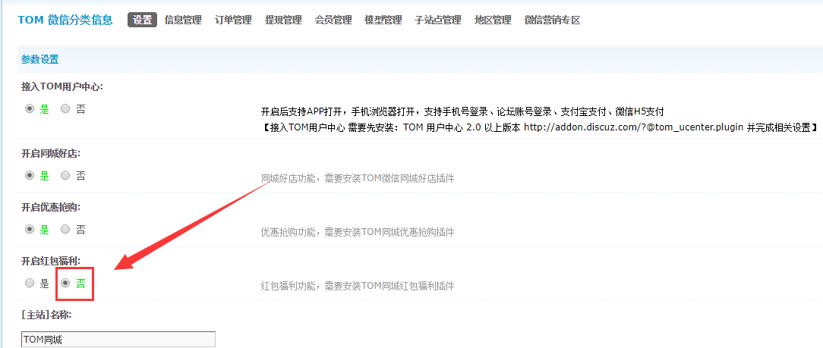](http://www.tomwx.cn/source/plugin/tom_editor/editor/attached/image/20180131/20180131022925_67030.png)

**第二步：关闭关注提示**

[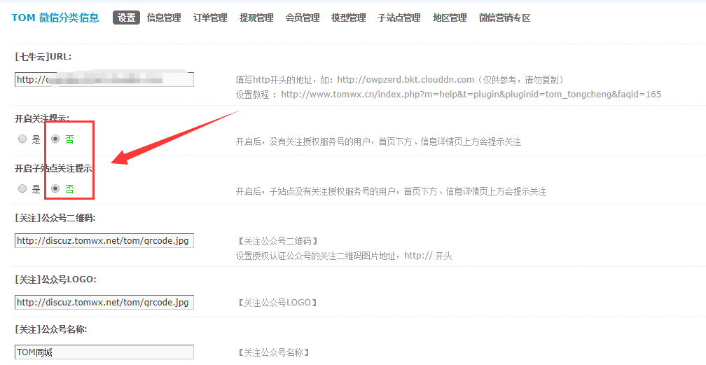](http://www.tomwx.cn/source/plugin/tom_editor/editor/attached/image/20180131/20180131023047_16011.png)

**第三步：删除首页红包链接**

[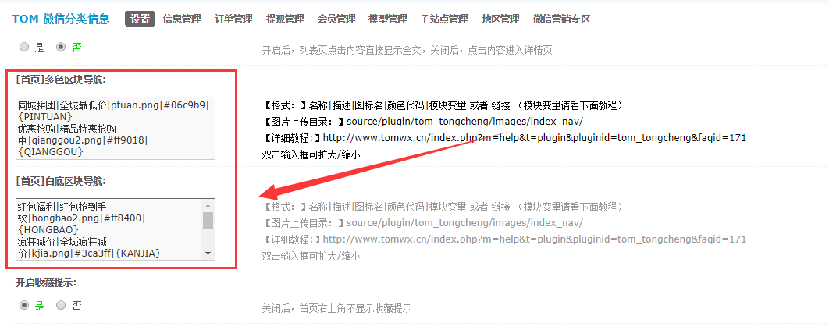](http://www.tomwx.cn/source/plugin/tom_editor/editor/attached/image/20180131/20180131023108_42253.png)

**第四步：删除底部导航红包入口**

[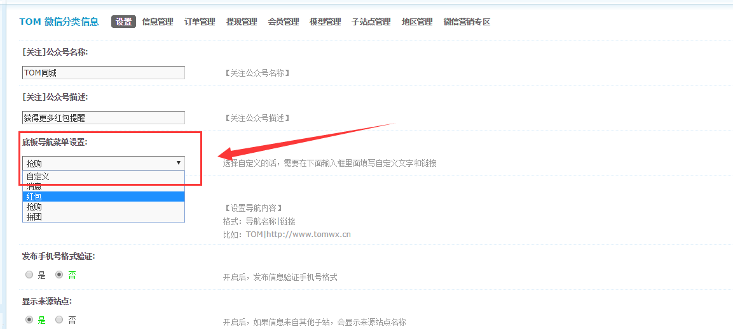](http://www.tomwx.cn/source/plugin/tom_editor/editor/attached/image/20180131/20180131023143_96930.png)

**第五步：关闭红包插件**

[](http://www.tomwx.cn/source/plugin/tom_editor/editor/attached/image/20180131/20180131023301_57779.png)